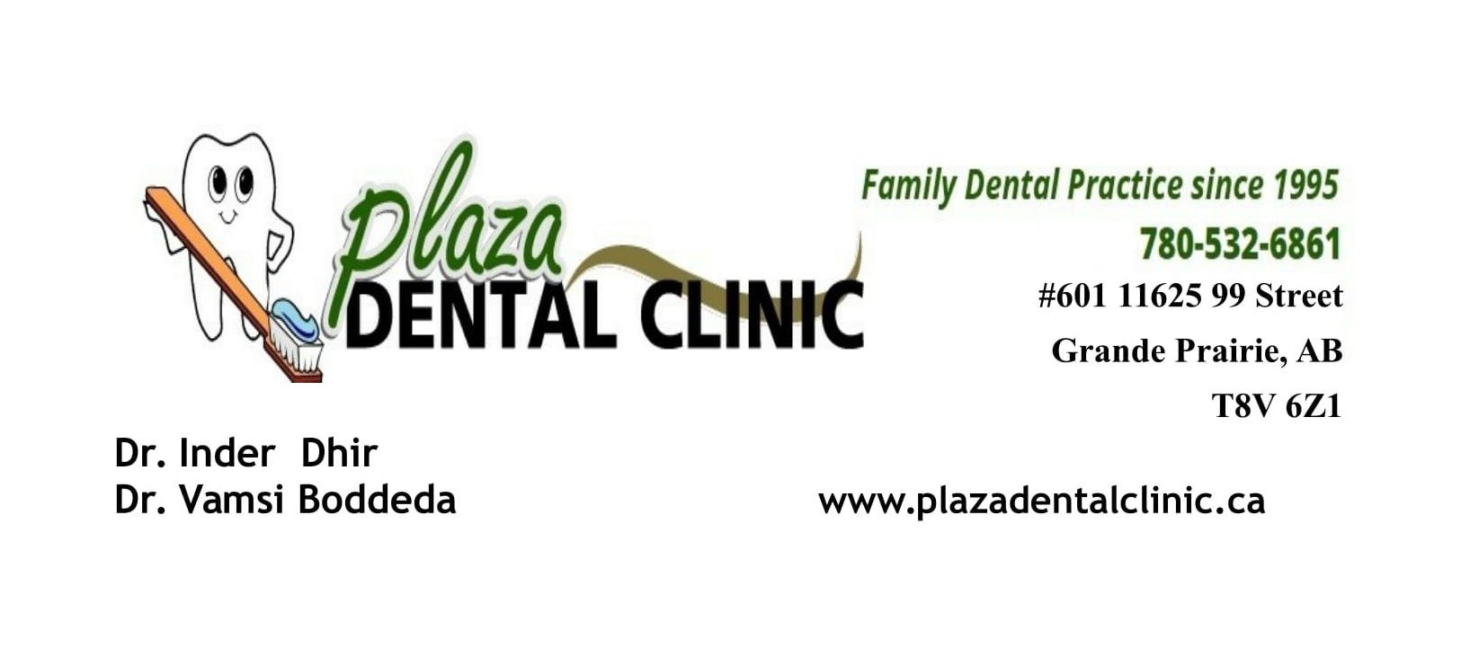

POST – EXTRACTION
INSTRUCTIONS

- Keep biting on cotton gauze for about 30 minutes, if you find the area is still bleeding use extra caution.
- Eat only soft foods for the next 24 hours
- No rinsing, smoking or alcohol for the first 24 hours ( no mouthwash)
- Use warm salt water to rinse after the first 24 hours
- Do not drink anything through a straw as this may cause prolonged bleeding
- Feel free to call our office if you have any other questions or concerns
- 7805326861 office Number
- 7809784056 Dr Dhir's Cell

