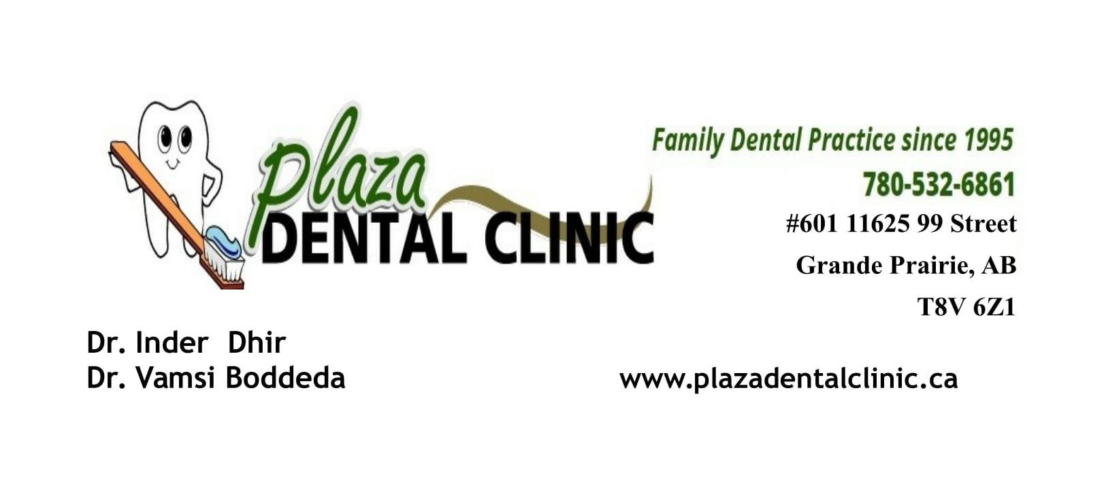
Pre-op Instructions for Oral Sedation
- Nothing to eat 6 hours prior to dental treatment. Sips of water is ok
- Do not take medications unless told to do so by Dr Boddeda.
- You will need a ride to and from your dental appointment. (a taxi is not allowed)
- Must be supervised for 3-4 hour after oral sedation appointment.
- Wear comfortable clothing.

If you have any question please call the clinic at 7805326861.

